A Web Atlas for Geographical Education –
New Approaches and Implementation

Hansruedi Bär, Juliane Cron, Philipp Marty, René Sieber, Lorenz Hurni
Institute of Cartography, ETH Zurich
CH-8093 Zurich, Switzerland
{baer, cron, marty, sieber, hurni}@karto.baug.ethz.ch

In the last years, the user interfaces of interactive atlases have much converged. There is a tacit agreement of how typical function such as navigation and queries are accomplished. The authors ask the question if such functions suffice and what else might be valuable with respect to school atlases. In the following paper, two partly new approaches, the ideas of synchronized maps and text-assisted communication are presented and their benefit for school atlases is discussed.

INTRODUCTION
According to Hüttermann [1998], working with maps in geographical education fulfills the following tasks:

- Elaboration, presentation and transfer of spatial information.
- Development of the students’ orientation pattern by acquiring the world’s topographic structures.
- Acquirement of map skills such as reading, understanding, interpreting, evaluating, and making maps.

Atlases with their wide range of different maps are important aids in performing the above-mentioned tasks. But it’s all the same necessary that their contents fit the purposes of the schools. For printed atlases, there is already a long tradition in designing specialized atlases for educational use. For example, the Swiss World Atlas [2006], the most widespread printed school atlas at secondary school level (12 to 19 years old students) in Switzerland looks back to more than eighty years of history. Recently, the editors of this atlas started a new cooperation with the Institute of Cartography at ETH Zurich concerning a supplementary Web atlas version. The expected added value of such an interactive atlas is that it will support the students more efficiently and will have a long-term effect in accomplishing the above-mentioned tasks. In order to reach this goal, not only the contents but also the kind of interactivity, the functionality and the design of the user interface have to be adapted to the purposes of the schools.

This paper shows by means of two real examples how the Web version of the Swiss World Atlas plans to fulfill such added value. The first example addresses the difficulties when unexperienced students have to compare maps at different scales [Rinschede 2003]. The approach of the so-called synchronized maps uses two or more maps at different scales, showing the same location at the center of the map windows. When panning one map, all dependent maps are moved such that they always point to the same location within the map window. This results in different speeds of adjustment of the differently scaled and occasionally differently oriented maps. This approach is intended to support the students in learning how to compare different scales and to estimate real distances, which are considered as main skills for interpreting maps.
The second example is related to map search. Instead of using trial-and-error methods when searching for locations or maps, the students are invited to precisely formulate their query before starting the action. This happens by means of a search form with both, spatial and thematic choices and restrictions. Additionally, an exemplary and partially text-based interaction style assists unexperienced students in completing the form. Finally, this approach should teach the students to develop appropriate search strategies, which is also strongly requested by teachers for geographical education [Marty 2007]. Moreover, students are animated to develop a spatial orientation pattern by entering the geographical context of the desired location.

APPROACH 1: SYNCHRONIZED MAPS
Taking a look at contemporary interactive atlas systems reveals that most atlases obey a single map approach. Typically, a map user chooses a map, and – if their questions are not yet answered – proceeds to the next map. Window-based systems allow the simultaneous view of two or more maps but there is generally no interrelation between such maps.
In the pioneering stage of interactive atlas systems, the size of computer screens – compared to that of a typical paper map sheet – has been much too small to think of a simultaneous view of map sets. Still today, the prevalent method of map comparison is to superimpose an additional map. With the advent of larger displays and high-resolution screens, the restriction to single map views is no longer justified and in future, even larger displays can be expected.
The term “synchronization” or “to synchronize” is of ancient Greek origin and has the meaning of “being of the same time”. Today, the word is used in many different contexts ranging from sports to computer technology. We suggest to employ the expression “synchronized maps” for a technique that invokes an action simultaneously to a set of maps. More specifically, manipulations on a single map will be reflected instantaneously by all maps belonging to the same map set. Synchronized maps explicitly make use of the relations and dependencies that exist between different maps. One of the most interesting applications is a set of maps that show the same location at the same time.
The idea of synchronizing maps or related documents has been around for quite a long time. Many interactive maps and atlases rely on inset maps that are used to navigate a map [Atlas of Switzerland 2004, Google Maps 2007]. Also, some image and graphics application programs make use of synchronized images in order to control the location of a large image by a movable rectangle within a frame. Basically the same idea is followed by some more sophisticated text editors that are able to dynamically track corresponding blocks of different text versions. Up to now, synchronized maps have been used in a rather rigid way. Typically, there is a fixed small-scale map that controls the position of a large-scale map. The coupling is usually two-way: moving the map directly also causes the small-sized map to reflect the new position immediately.

In the past, several techniques have been developed to enable map comparison on a single map. The simplest approach is to superimpose a map on top of an existing map. The problem that the superimposed map might obscure large parts of the map underneath has been circumvented by regularly turning the superimposed map on and off, by changing the order of the maps or by assigning variable transparencies that can be controlled by the user. The overlay technique might work fine for maps having the same origin. Provided that the maps share a common scale, map projection, and orientation, superimposition is potentially applicable, although accuracy and the degree of generalization account for the final appearance. Since maps are generally not specifically designed for superimposition, they may suffer from partial occlusion, excessive map object density, low contrast, or unintended color mixture.
The principle of map or image synchronization has already been implemented in various software applications. For instance, in graphics applications, a scaled-down image and a rectangle are used to show the currently visible part of an image in a window. Moving the rectangle causes the image to move in the window based on proportional mapping between image and navigation tool.
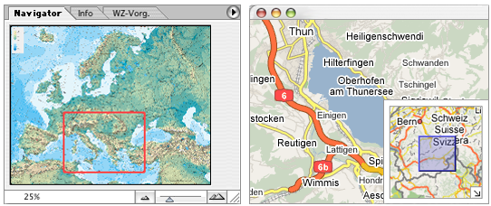
Figure 1: Navigation tools. Left side: Photoshop. Right side: Google maps.

Figure 1 on the left shows Photoshop's navigator tool. The red-framed rectangle is used to move the image in the window. A similar but slightly improved tool is shown on the right side, taken from Google maps. After dragging, the blue rectangle is centered again while the under laying map is adjusted to show the corresponding place. The inset map only shows a small part of the whole map at a time.
A basically similar approach to map synchronization is followed for text comparison. Two different versions of text are synchronized such that corresponding lines always match, independently from line insertion, deletion, or modification. Scrolling a text in one window results in an appropriate scrolling of the text in the other window, and vice versa. Figure 2 shows a screenshot from a text comparison tool as implemented in BBEdit's text editor.

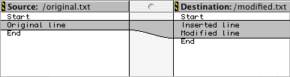
Figure 2: Synchronized text versions

Our approach is to generalize the synchronization of maps in such a way that any map is potentially able to drive any other map. In particular, synchronization shall be independently from the scale of the maps involved, their orientation, map projection, accuracy, the degree of generalization, and even from the type of data the maps are based on. The only precondition, however, will be that the maps share at least a common area.
Synchronized maps typically show the same location at the same time. Moving one map causes all depending maps to move to the new location at once, possibly slightly delayed due the time needed for map update. The most obvious candidate for the common location is the center of the interior window. This location guarantees a symmetry for all synchronized maps, although there might turn up some problems at the map borders, as will be discussed later. It might be necessary to mark the common location by a symbol which might also disappear after the new location has been established.

By far the simplest method for map synchronization is based on pixels. This works fine as long as the maps are showing the same extent. A more flexible method might use relative positions, provided that the maps show the same extent at different scales. The most flexible method is to map the center points to a common coordinate system. Using homogeneous 2D coordinate transformations, different map scales and different maps orientations can be handled. By concatenating an inverse transformation, followed by a forward transformation, affine transformations between the center points of different maps can be realized. But to take the most out of synchronized maps, all maps need to be geo-referenced. This means that their forward and inverse map projection have to be known. Therefore, in order to synchronize two maps, an inverse transformation is first applied to the center position, followed by an inverse map projection. The location of the center point in world coordinates is then sent to all dependent maps, forward projected and transformed to finally get the position of the synchronized map in the local graphics coordinate system. Figure 3 shows the steps needed for a map that synchronizes two dependent maps. For simplicity, the figure only shows the communication in one direction, but the synchronization should basically be to-way.

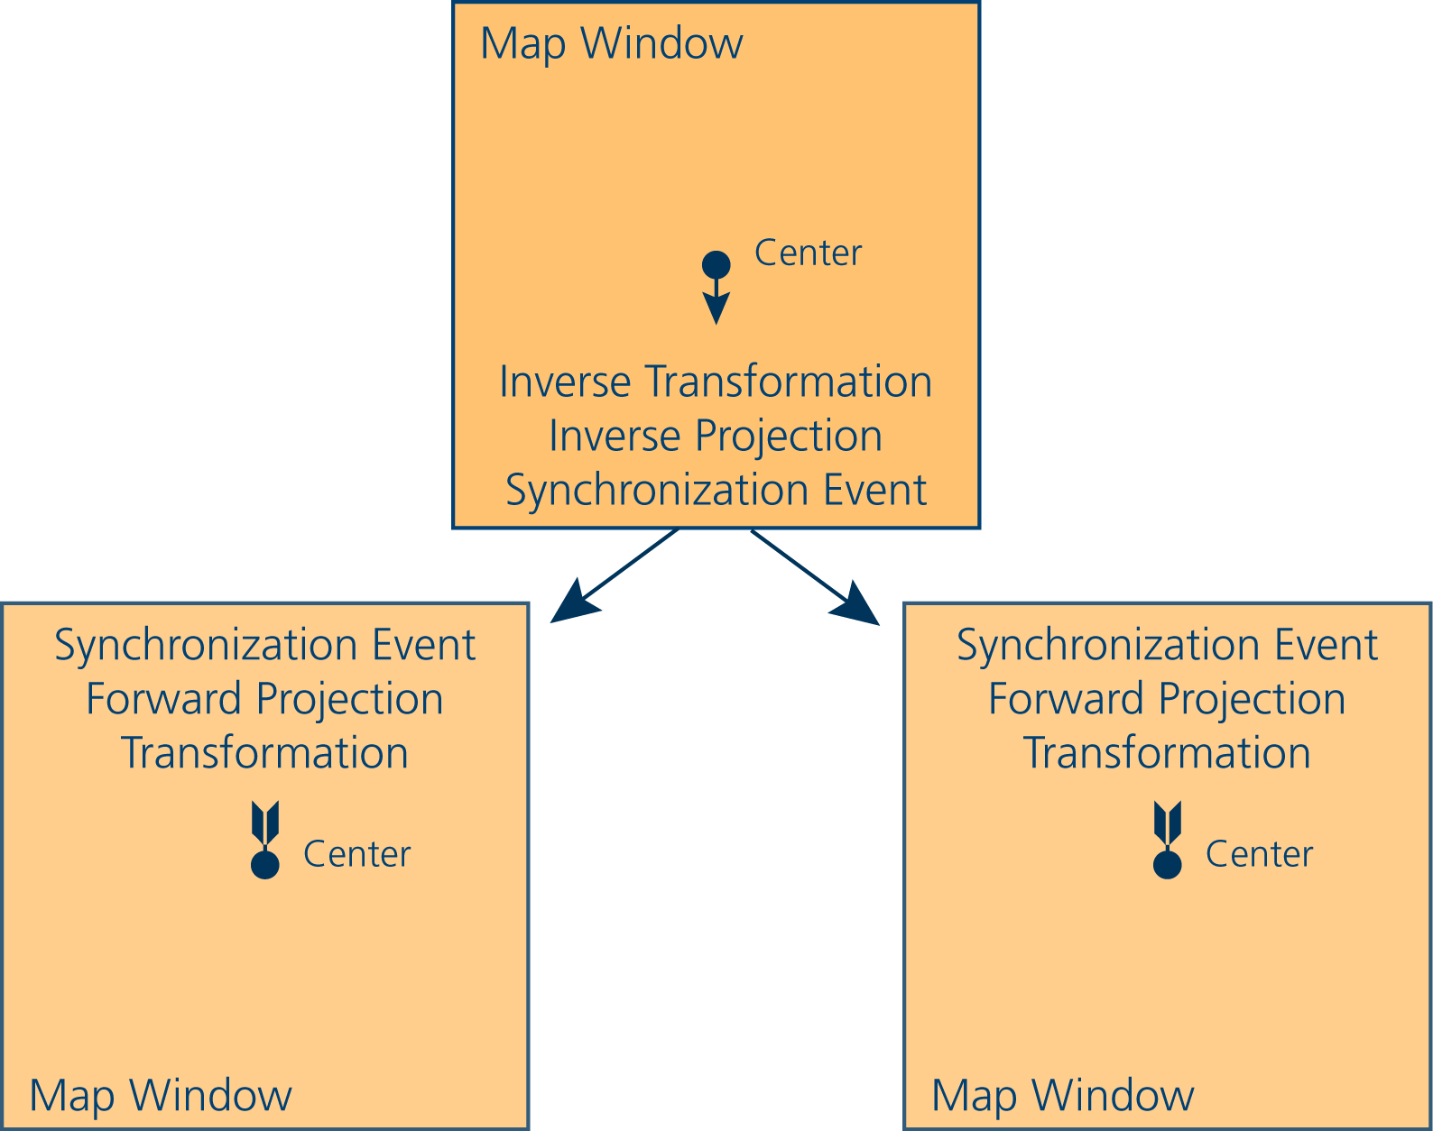
Figure 3: Steps needed for generally applicable map synchronization.

As long as the map projection is only used for synchronization, accuracy of the map projection is of minor importance. If the projection system of a map is not known, if the map is distorted or discontinuous, it might also suffice to specify a number of ground control points and approximate the projection by interpolation.

One of the most interesting features of map synchronization is that a loose coupling can be realized. A sender of synchronization events doesn't need to know anything about the receiver and in fact, it shouldn't make any assumption about the receiver. The lack of such restrictions makes map synchronization an ideal technique for inter-application communication. Furthermore, it is even possible to achieve map synchronization across a network using a common Internet protocol. In order to be able to receive remote synchronization events, a map application needs to implement a simple server that is able to listen for synchronization events. Implementing further events, a map application can even be controlled over a network by a remote interface.

We would like to point out that map synchronization is not only a technique to handle sets of maps but a rather universal concept that turns up in most interactive atlas systems. Map comparison as well as spatial navigation, search functions, guided tours, user-controlled bookmarks but also thematic navigation can be considered under the aspect of synchronization. We are also convinced that the consequent application of this concept ultimately leads to more versatile, inter-operable, and more consistent applications.
The concept of synchronized maps can possibly be extended to 3D maps. It is assumed, however, that the center point within a map window cannot play a central role. When moving a 3D map, the central window point is destined to jump frequently or may even be outside the map. If 3D map will have to be synchronized it is rather a reference point that has to be controlled by the user.
Additionally, there is no restriction that map synchronization can only occur between maps. In fact any two or more documents that contain locational data, either explicitly or implicitly, can be used for locational synchronization. In such a case, it would possibly make more sense to speak of locational or geo synchronization rather than of map synchronization. For example, in a multimedia application, having a set of geo-referenced images, such images can be pinned in the geo-space and navigated by a map, bringing the centered image to the foreground. Instead of using two maps, we might consider replacing one map by a table containing locational data (geographical coordinates, among others). Selecting an entry in the table will cause any maps – if possible – to move to the desired location. The table can be of any provenience, but it would not be unusual to create the table from a map itself. Clicking on a location in a map may not only cause the table to look for an entry containing a location most closely to the requested one, but might also add the location as a new entry in the table. Thus, a user-created list of geographical location can be created and used in a number of ways such as personal map indices, book marks of an atlas, or, if appropriately symbolized, as a way to create user-defined point symbols maps. Adding the table application a set of tools such as sorting functions, regular expression, formulas, and classification provides a simple but powerful way for working with maps and geo-data in an analytical way. Finally, synchronization can occur between two tables that contain geo-referenced locations. Choosing a location in one table causes the depending tables to show the locations that are most closely to the desired location.
Furthermore, it does not necessarily be the user who selects all maps to be synchronized. Having a collection of geo-referenced maps, a specific map can be replaced by a request for a map containing a given location. A database is then required to turn the request into an appropriate map document, possibly within a given context such as the range of scales or the map thematic.
A remotely related application might consider text documents that can be used to immediately show any contained geographic place names. Scrolling a text might expose place names, which, when recognized by a geographic name database can be used to show the locations on a map. An application might be an atlas of literature that connects written places names to locations on a map.

There is currently a prototype version of the Swiss school atlas under construction. This atlas is designed as a Web atlas and its contents is accessible either by a modern Web browser or a Java Web start application, with the first offering simple access without any installation requirement, and the second providing extended functionality. At the current stage, only raster maps are provided. Tiled map images guarantee a fast loading of the maps, whereas decomposition into map layers offers an individual arrangement of the map contents. The map contents are described by a XML files. Additionally, the Java version incorporates a spreadsheet application to handle and manipulate geographical locations, a partial Java port of the PROJ.4 map projection library for map synchronization, and a basic HTTP server that allows the atlas control by an external interface. This implementation and the provided tools enables to demonstrate the principle of map synchronization.
The implementation also reveals a number of problems that have to be faced, as will be mentioned in the following. When synchronizing maps, there is not much to care about as long as the maps completely share a common area within their windows. Things are getting more difficult when a map reaches the map border. One question is whether a map should completely ignore synchronization events when it reaches the map border or whether it should move to a position that is most close to the desired position. Shall the map stop at the map border or shall it go beyond and how much if it may? Does it matter if one map cannot drive another up to the map border? Figure 4 shows how synchronized maps may restrict the visible map area.

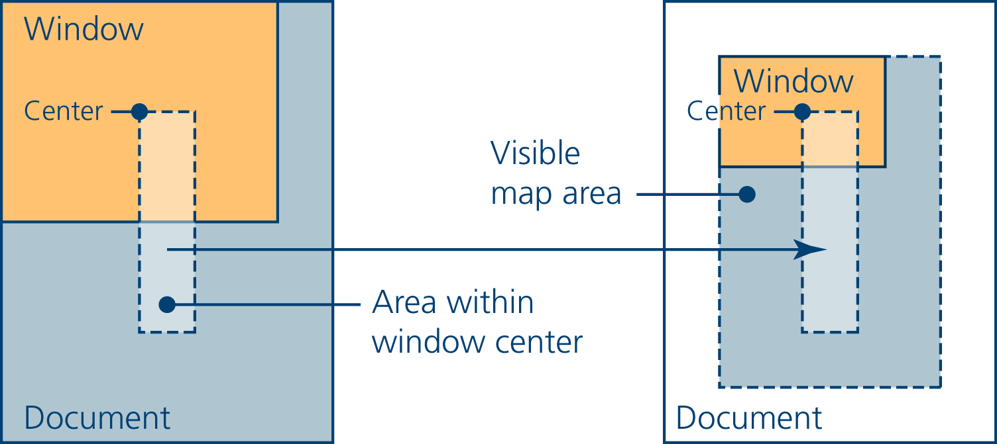
Figure 4: Possible restriction of visible map area in synchronized maps.

There is no problem with the probably rare case where map extent and window size coincide. If the window of the driving map is larger than that of the dependent map, the map cannot be moved up to the map border. Given a map in a window, the area in the map document where the map location at the window's center position may possibly move to is restricted to an area that is smaller than the document. More precisely, this area is diminished by the size of the window. If the dependent map window is smaller than this one, the visible map area will be smaller than the map document, the inset being the difference between the sizes of the corresponding map windows.

To realize fully synchronized maps, all involved maps need to be able to send and receive synchronization events. There are, however, cases where map synchronization is not intended. Comparing two different parts of a map and moving them independently from each other is a basic task as well. Therefore, synchronization also needs to be able to be suppressed. This can happen on the receiver and the sender of synchronization events.
Synchronized maps mean that there is always more than one map on the screen at a time. It might be necessary to provide a few utilities that do the layout of the map windows. In particular, functions that optimally use the limited screen size and regularly distribute the maps without windows obscuring each other are required. Currently, there is a column and a row oriented layout implemented, forcing the window to similar sizes.
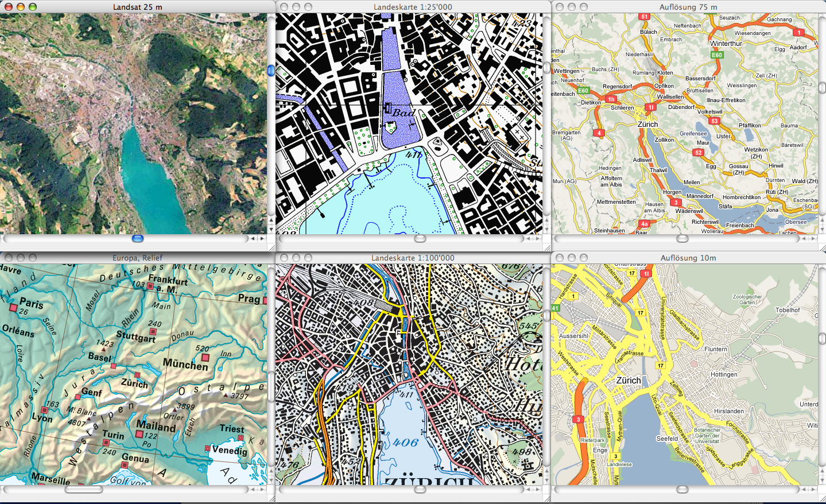
Figure 5: Layout of a set of synchronized maps

Driving a large-scale by a small-scale map results in a transmission of small steps to large steps. This makes it difficult to precisely control such a map. It might be necessary to smooth out large steps by interpolating the steps along the translation path.

APPROACH 2: ATLAS COMMUNICATION VIA TEXT-BASED INTERFACES
The wide dissemination of computers and their fast developing performance combined with increasing Internet speed are responsible for the growing use of digital media in geography and cartography. The classic printed atlas is more and more replaced or supplemented by electronic atlases on CDs or on the Internet. Such interactive atlases are showing an increasing growth in comprehension, functionality, and, particularly, in interactivity. For this reason, the communication process becomes a rising challenge.
Communication is a process by exchanging information between individuals through a common system of symbols, signs, and behaviour. In interactive atlases, communication is based on the usage of symbols, text, and pictures as well as speech.
A fundamental part of communication is interaction. Interaction means two-way communication (flow of information) between human and machine. Interactivity in relation to atlases enables the achievement of interactions, like data and map manipulation. Consequently, interactivity is the most important added value to an interactive atlas and the level of interactivity defines the scope of applicability.

One of the simplest approaches to modelling interactive systems is to describe the stages of actions users go through when faced with the task of using such a system. Marinilli [2006] could identify roughly seven steps for a typical user interaction with an interactive system: forming the goal and the intention, specifying and executing the action, perceiving and interpreting the systems state, and finally, semantically evaluating the outcome (fig. 6).
Let’s apply these interaction steps to a real example in a geography lesson. The students are asked to figure out the annual rainfall of Santiago with the help of the “Swiss World Atlas – interactive”. This task matches the goal the students have to form. After that, the students’ intention is to use the atlas to find a map of Santiago on the subject of rainfall. A search form in the atlas enables to specify the action. So, the student has to fill in, wherefrom (Santiago) and to what subject (rainfall) the map should be about. By confirming the input he or she starts the action. In the following, a map will be displayed and the student is asked to perceive and interpret the map. Finally, he or she evaluates the outcome by comparing it with the primary goal.

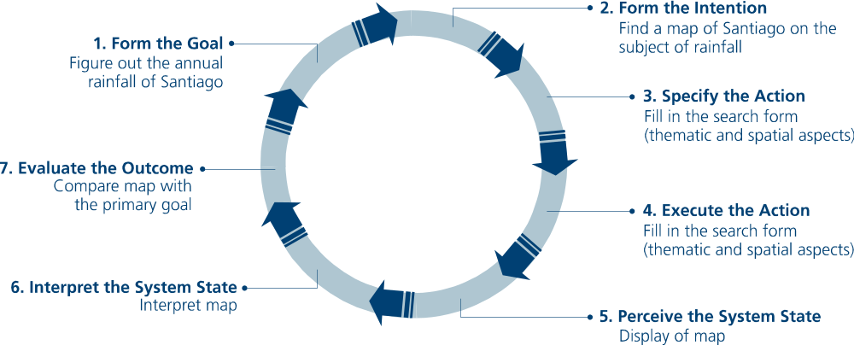
Figure 6: The seven stages of interaction, using the example of map search.

Troubles arise if the displayed map doesn’t match the primary goal. For example, if Santiago de Cuba is shown instead of Santiago de Chile. This means that the student would have to start the query again. Ideally, this should already be prevented in the first run of the interaction by pointing to the different cities called Santiago. After starting the action, the student should be requested to restrict his or her query, of course with the help of additional information about the different options. There are several possibilities to continue, depending on the kind of the implemented human-machine interaction.
In literature, the different kinds of human-machine interactions are called interaction styles. «An interaction style is the basic mode of interaction. It is linked to in-/output-media, abstract from precise physical devices. The fundamental decision, which interaction style supports an application, should be resolved at an early stage» [Preim 1999, pp. 525].
A distinction is drawn between text-based and graphically oriented interaction styles. Text-based interaction styles are interactions using a command language or a natural language. Graphical interaction styles use direct manipulation, menu selection, and WYSIWYG (What You See Is What You Get). Due to their persuasive usability, intuitive and easy manipulation and their high level of interactivity, the communication of present user interfaces is in most cases visual.
Text-based interfaces are distinguished from graphical user interfaces. Users must recall commands to initiate actions. The interaction via text-based communication is hardly used. But from an educational point of view, it can be argued that with the advent of graphical user interfaces and multimedia products, the literate skills of students risk the danger of turning into a mere recognition vocabulary. It is intended to counter this tendency by assisting them in the use of a proper terminology, supporting text-based interactions with appropriate feedback and the design of a geographic database that builds on language, concepts, and relations.
Interaction using a command language is the original form of interaction between human and machines. The prerequisite to execute interaction via command language respectively to be capable to navigate within an application is the user’s knowledge about the language. The atlas shall be run by a large number of users but also be suitable for computer-skilled students. On this account, the idea of a standardized map communication language arose.
For text-based communication, the instructions are entered via the keyboard. The language will be designed such that the interpretation of the user’s input will be mostly unambiguous and processed fast enough. The keywords of the language are named in that way, that less letters might be sufficient to interpret commands. For command languages, this feature is also called command completion.

Human learning, problem solving, and memorability are greatly facilitated by a meaningful structure. If the communication language is well designed, users can recognize the structure and can easily memorize it. For example, if users can uniformly handle characters, words, and sentences, such meaningful patterns are easy for them to learn, apply, and recall. The design of a language is therefore conducted by some basic goals [Shneiderman 2005]: precision, compactness, ease in writing and reading, completeness, speed in learning, simplicity to reduce errors and ease of retention over time.
With a graphically interaction style, students could choose among all different places called “Santiago”. With a text-based interaction style, students are informed about other places sharing the same name and afterwards requested to enter the geographical context.
The key advantage of the text-based interaction style is the increasing learning effect by repeating the combination of terms. Basically: the naming of places and objects, either actively (when entering a request) or passively (as a comment to a request). Using a graphical-oriented interaction style may guarantee a quick display of the result, but probably at the cost of a lasting learning effect.
Apparently, the combination of text-based and graphical interaction is an alternative approach (fig. 7). With a graphical interface, the students immediately know how to use such a system, but with a text-based interface they learn how to name things which is most essential to education.

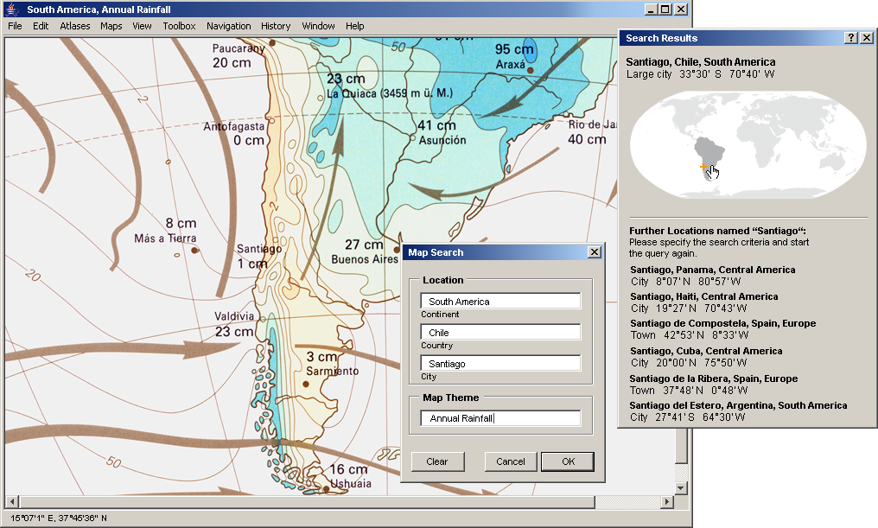
Figure 7: Example of map search via text-based atlas interface, in combination with graphical interaction

Combining several interaction styles may be appropriate when the required tasks and the knowledge of the users are diverse. For example, commands can lead the user to fill in a form where data entry is required, or menus can be used to control a direct-manipulation environment when a suitable visualization of actions cannot be found. Also, keyboard commands can provide shortcuts for experts who seek for more rapid performance than mouse selection [Shneiderman 2005].

OUTLOOK
In this paper we presented two approaches that are destined to sustainably improve the power of interactive atlases for educational purposes. The first approach builds on the idea of synchronized maps and shows what it might contribute to an interactive atlas from a didactical as well as from an implementational point of view. Starting from the assumption that literate skills are an important issue in geographical education as well, the second approach shows how a supplementary text-assisted communication style might contribute to this aim.
We further strongly envision an atlas that is capable to work and experiment with rather than just to look at. Students shall be able to play a more active role when using an atlas. In particular, they shall be animated to exchange data with other application programs they already know, to visualize their own data within the atlas environment and to include maps in their own work or home page. An atlas must therefore partly leave the idea of a fully designed artwork for presentation and find back a system consisting of a collection of tools. Students should not get the impression that everything has already been done for them. At the same time, they must be supported in such a way that their active role doesn’t exceed a level of frustration due to excessive demands. On the part of the atlas, assistance shall be offered by commented interactions or by an integrated help or tutorial.

REFERENCES
Atlas of Switzerland 2 (2004). DVD or 2 CD-ROMs. Swiss Federal Office of Topography, Wabern.
Google Maps (2007): Available from: http://maps.google.com/maps. Last access: May 2007.
Hütterman, A. (1998): Kartenlesen – (k)eine Kunst. Einführung in die Didaktik der Schulkartographie. Oldenbourg, Munich.
Marinilli, M. (2002): The Theory Behind User Interface Design, Part One. Available from: http://www.developer.com/design/article.php/1545991. Last access: May 2007.
Marty, P. (2007): Analyse der Nutzeranforderungen an den “Schweizer Weltatlas interaktiv”. Diploma thesis. Institute of Geography, University of Zurich. Available from: http://www.ika.ethz.ch/teaching/ Diplomarbeit-Marty.pdf
Preim, B. (1999): Entwicklung interaktiver Systeme: Grundlagen, Fallbeispiele und innovative Anwendungsfelder. Springer, Berlin, pp. 525.
Rinschede, G. (2003): Geographiedidaktik. Grundriss Allgemeine Geographie. UTB Schöningh, Paderborn, Munich, Vienna, Zurich.
Shneiderman, B. & C. Plaisant (2005): Designing the User Interface: Strategies for Effective Human Computer Interaction. Addison Wesley, Boston.
Swiss World Atlas; Schweizerische Konferenz kantonaler Erziehungsdirektoren EDK (Publ.) (2006): Schweizer Weltatlas – Atlas Mondial Suisse – Atlante Mondiale Svizzero. Lehrmittelverlag des Kantons Zürich, Zurich.

